**Project Design Phase-I**

**Solution Architecture**

|  |  |
| --- | --- |
| Date | 17 October 2022 |
| Team ID | PNT2022TMID45948 |
| Project Name | Project - Predicting The Energy Output Of Wind Turbine Based On Weather Condition |
| Maximum Marks | 4 Marks |

**Solution Architecture:**

Solution architecture is a complex process – with many sub-processes – that bridges the gap between business problems and technology solutions. Its goals are to:

* Wind power generation differs from conventional thermal generation due to the stochastic nature of wind.
* Thus wind power forecasting plays a key role in dealing with the challenges of balancing supply and demand in any electricity system, given the uncertainty associated with the wind farm power output.
* The inlet condition of the wind farm is forecasted by the auto regressive model.
* We report on the correlation of the different variables for the energy output.

**Example - Solution Architecture Diagram:**

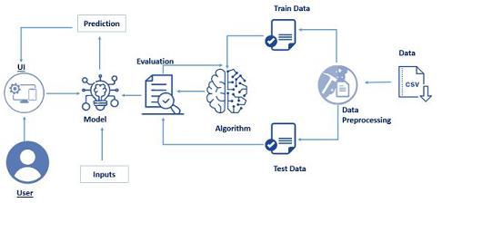

Figure 1: Architecture and data flow

**Reference: https://github.com/SmartPracticeschool/llSPS-INT-3437-Predicting-the-Energy-Output-of-Wind-Turbine-Based-on-Weather-Conditions-Watson-Auto-**